Property Shop 2026 Schooling Show Series
Offering USDF/USEA Dressage, WDAA Dressage & CT
West End Farm – 12001 Donahoo Rd, Kansas City KS 66109

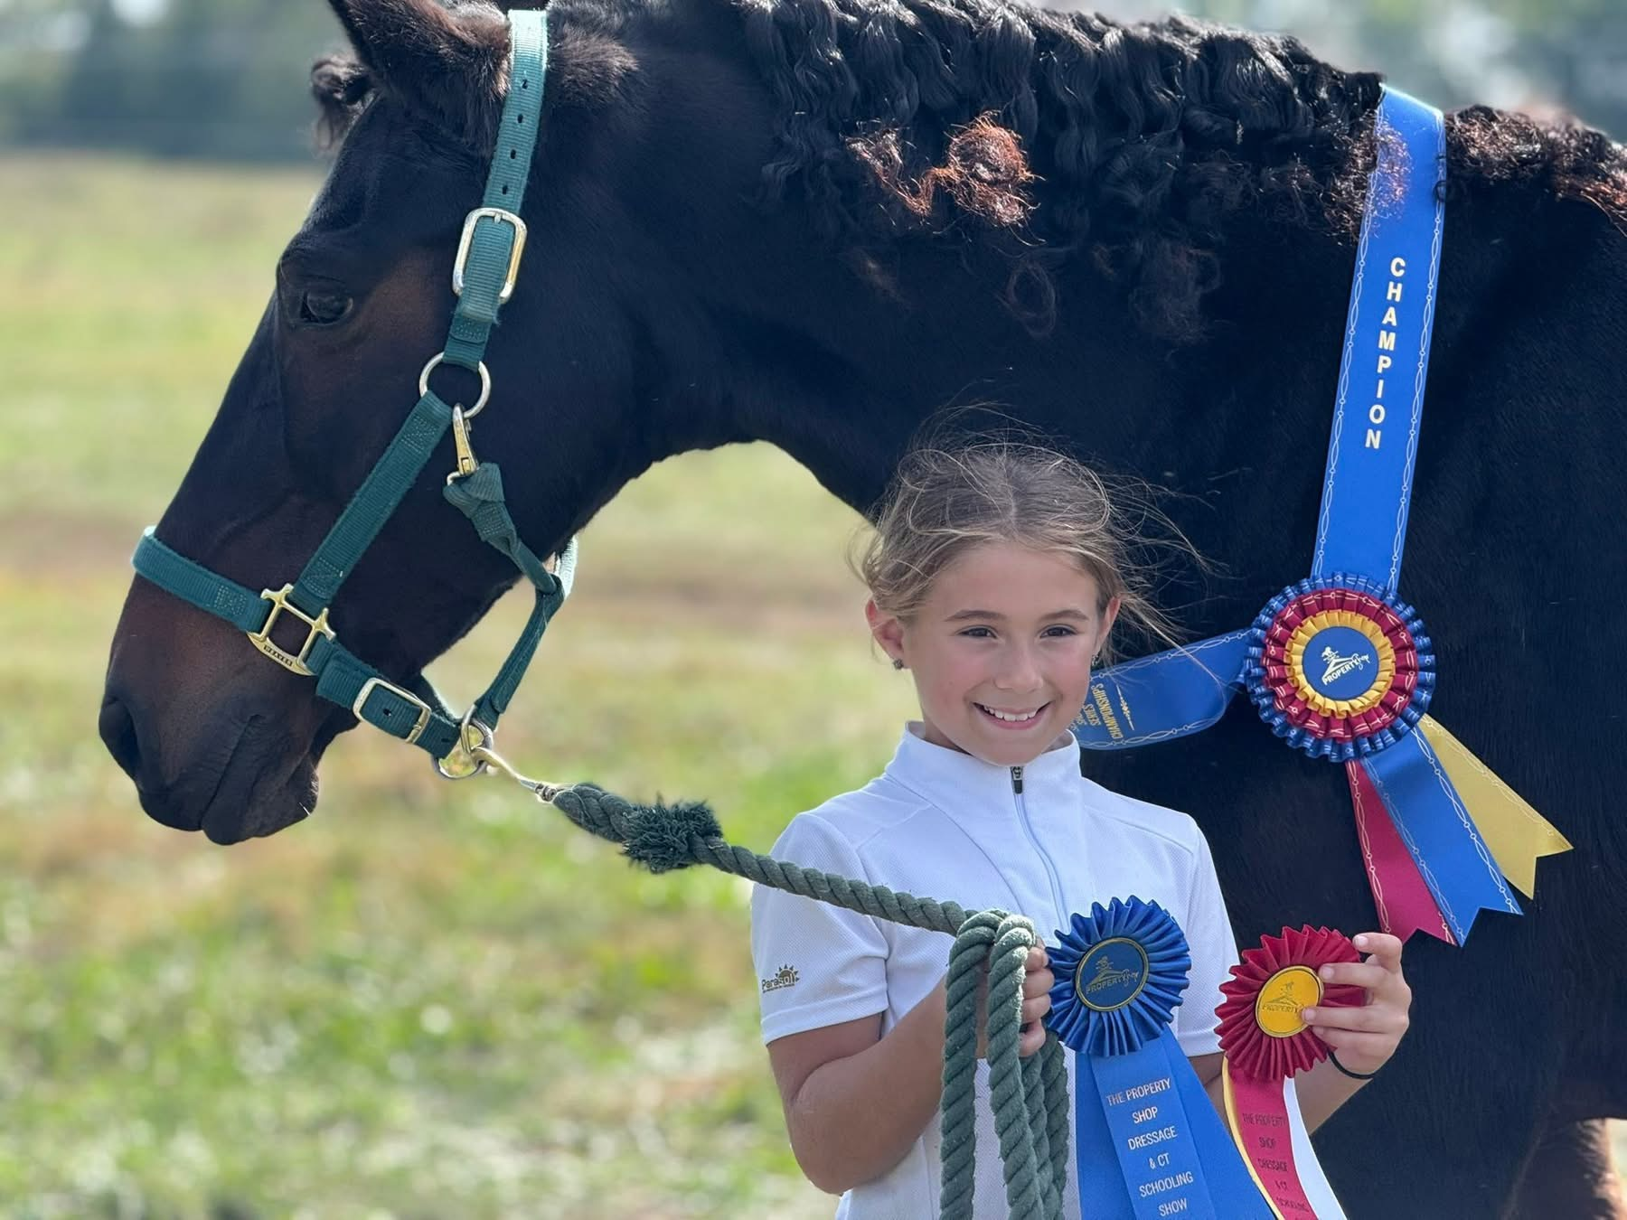

Show Date | Judge | Entries Open  10 AM | Entries Close  9PM**
Show #1 June 27, 2026  AQHA Western Dressage Point Eligible | Susan Lang | 6/9/26 | 6/23/26
Show #2 May 30, 2026 | Becky O’Bea | 5/5/26 | 5/26/26
Show #3 August 1, 2026 | Jana  Wagner | 7/7/26 | 7/28/26
Show #4 October 10, 2026  Open Show & Championships | Katelyn Razumovsky | 9/15/26 | 10/6/26
Rain Date Shows | TBD | TBD | TBD
**Management Reserves the Right to Close Show Entries Early Should Show Fill Prior to Close Date
Show Manager & Secretary – Maggie Stonecipher 913-908-6992 or PropertyShopSchoolingShow@gmail.com
Jump Manager – Sarah Berkowitz
Scorer & Office Manager - Roxanne White
Divisions
- Junior (JR) – Riders are eligible to compete in these classes until the end of the calendar year in which they reach the age of 18.
- Amateur Adult (AA) – Riders must qualify under USEF Amateur rules and not hold any Professional Trainer, Rider or Coach Status.
- Open (O) - Riders have no restrictions in these classes.

Classes
- Classes Per Day – Multiple riders may compete on the same horse however horses are limited to 3 dressage tests a day.
- Consecutive Levels - Horse may enter no more than 2 consecutive levels at any one show.
- Class Awards – Ribbons to 6th place for each class. Divisions may be run concurrently and pinned as one class but will be awarded separately when entries in that Division meet or exceed 3 entries.
- CT Classes – Note there are new tests for 2026!! The Combined Tests will be run under USEF Eventing Rules to the best of our ability. The exception is that show jumping rounds will not be timed. Please note that readers are not allowed for dressage tests, no unauthorized assistance is allowed, and you must wait to begin your show jumping round until the judge has signaled. Tadpole and Green Bean divisions will have no oxers and no fill. All show jumping courses for Starter and higher divisions will be designed based on USEA's published regulations.
- No unauthorized assistance. As per the USEF Eventing Rules, unauthorized assistance may be penalized by Elimination and is defined as: "Any intervention by a third party, solicited or not, with the object of facilitating the task of the Athlete or helping their Horse." Unauthorized assistance includes speaking or gesturing to the rider during competition.
- Wait for the show jumping judge to give an audible signal (typically bell or whistle) prior to starting your course. As per the USEF Eventing Rules, "An audible signal is used to communicate with the Athletes. The signal is used to give the signal to start and activate a 45 second countdown. 45 seconds is the time an Athlete can spare before commencing their round."
Entry Procedures –
- Entries open at 10 AM. Entries sent prior to 10 AM will NOT be accepted.
- Only one Horse/Rider combination per entry form.
- Lead Line Class will be offered at each show. Open to riders under 10 yrs old NOT entered in any other class. Riders to be led by Adult over 18 yrs old. Any discipline. Riders will receive a prize and ribbon.

- Entries may be
- mailed to 10377 Nemaha Rd, Oskaloosa, KS 66066 or
- emailed to PropertyShopSchoolingShow@gmail.com
- Payment –
- Payment must be received at time of entry for entry to be accepted! If you email your entry but mail your check, your entry will not be accepted until your check is received.
- PayPal Friends & Family Only, If you pay via Goods & Services you will be charged the PayPal Fees along with a $10 fee for your entry to accepted.
- PayPal Friends & Family to PropertyShopSchoolingShow@gmail.com
- Entry Acceptance – Entries will be accepted on a first-come, first-served basis and must include ALL fees, Coggins, signatures and payment in full.
- Wait List – Entries made after the Closing Date or if show closes early will be placed on a Wait List in order received. Should space become available, Rider will be given notice of entry being accepted into the show. All fees will be refunded should Rider not wish to fill an open space (written notice within 6 hours of notice of space available) or if no space opens.
- Coggins – A copy of current Coggins (within 12 months) required with entry.
- Cancellations/Scratch/Withdraw – Entries may be cancelled or withdrawn in writing prior to or on the closing date. Cancellations made prior to closing date will receive a refund of all fees. No Refunds for Cancellations after the closing date. Refund consideration due to veterinary or personal emergencies will be at sole discretion of Show Management.

Reserved Rights of Show Management –
USDF, USEF, WDAA, AQHA and USEA rules will be observed however Show Management reserves the right to make allowances and adjustments while maintaining the spirit of schooling shows. Show Management reserves the right to make changes to the Prize List at any time. Show Management reserves the right to add or change officials, refuse any entry without cause and make any changes deemed necessary for the safe and efficient management of these shows.

Conditions of Entry –
All competitors agree to hold harmless Maggie Stonecipher, The Property Shop LLC, West End Farm (including owners & staff), Sarah Berkowitz, Bell Mountain Equestrian LLC, and any show staff including volunteers from all claims for any damages, losses or injuries to person or property of the competitor or anyone accompanying same to the event. Under Kansas Law, there is no liability for an injury to or death of a participant in domestic animal activities resulting from the inherent risks of domestic animal activities, pursuant to K.S.A. 60-4001 to 60-4004. You are assuming the risk of participating in this domestic animal activity.

Show Information:
- Arenas & Footing – Warm-up Arena is sand footing and unfenced. Indoor Arena is dirt footing. Jumping Arena is sand footing and fenced. All Arenas will be dragged prior to the show with Indoor Arena also being dragged at lunch break at discretion of Show Management.
- Dressage Arenas –All tests will be conducted in a 20mx50m arena.
- Stabling – 25 stalls will be available and will include shavings. 5 stalls may be pipe corral panels. No outside shavings or straw. Any stabling requests much be included on Entry Form. Please use one name for stabling groups please. Stalls are assigned on a First-Come, First-Served basis.
- Arrival – No Friday arrival prior to 3pm and no arrivals after 7:30 pm without written permission from Show Management.
- Facility Hours – Please respect the facility hours. No access after 8pm on Friday or before 6:30 am on Saturday.
- Schooling – Indoor arena and warm up arena will be open for schooling 3PM to 7:30 PM on Friday, 7AM to start of the show and during breaks and lunch.
  - Jump arena is NOT available for open schooling on Friday but there will be time for warm-up schooling prior to each division on Saturday. See page 5 for New for 2026 Open Jump Fridays
- Trailer Parking - Parking will be in designated Parking Area up the hill east of all barns and arenas. Car parking will be in the open hay field on north side of property along driveway. Please note that NO security is provided, and all parking is at own risk. Do not leave valuables in vehicles or cars unlocked. Handicapped parking is available next to indoor arena.

Rules, Policies & General Information
- Dogs – No Dogs allowed on show grounds at any time with exception of Service Animals. This includes in trucks, trailers, cars, stalls, etc.
- Protective Head Gear – Anyone mounted at any time on the show grounds must wear protective headgear defined as a riding helmet that meets or exceeds ASTM/SEI standards.
- Ride Times & Stabling Assignments – Ride times and Stabling Assignments will be emailed by Thursday NOON prior to the show.
- Scheduling of Classes – Classes will be scheduled for the convenience of management and judges and may not run in consecutive order.
- Readers – Readers are allowed for USDF & WDAA classes at all levels for Open Show Classes but will only be allowed for Junior Riders under the age of 12 in Championship Classes.
- Lunging in Designated Area Only – Lunging is allowed on the north end of the warmup or in open field north of warmup. Only one person may lunge in the warmup arena at a time. Please be courteous.
- No smoking or vaping allowed anywhere on show grounds.

NEW FOR 2026 – FRIDAY OPEN JUMPING ROUNDS
Open Jumping Rounds are not only for those entered in the Schooling Show on Saturday, but for ANYONE wanting to get some practice jumping courses in a relaxed and fun environment!
• $20 per horse/rider combination per round includes warmup at selected division height and one round at that height. $10 for additional round at same height.
• Must pre-register using Entry Form and abide by all rules herein but there is no Office Fee.
• Rounds are not judged but rider will be excused after three disobediences.
• Coaches may coach during the round from outside the arena.
• The course on Saturday MAY be different than the Friday course.
• Rider does not need to be entered in The Property Shop Show on Saturday in order to take advantage of these Open Jumping Rounds on Friday! You just need to pre-register by closing date.
• Times will be determined based upon entries but we anticipate approximate times to be:
o 3:30-4:30PM Tadpole (ground pole) and Green Bean (18” cross rails),
o 4:30-5:30PM Green As Grass (2’) and Starter (2’3”)
o 5:30-6:30PM Beginner Novice (2’7” and up)
o Higher levels may be added if enough interested!!

Qualifying for 2026 Championship Classes
- Championships are open to horse/rider pairs who have earned qualifying scores between October 6, 2025 through October 8, 2026.
- Qualifying scores can be earned at Property Shop Dressage & CT Schooling Shows, KCDS Schooling Shows, KV Dressage, MAEA Schooling Shows, SLADS, Moffit Lake, KDEA and other Schooling Shows in USDF Region 4 with approval of Show Management.
- Earn a total of TWO qualifying scores at that level.
- It is not required that the horse/rider pair achieve a certain placing in the class, only the minimum qualifying score be earned.
- There is no limit to the number of horses on which a rider may qualify.
- Qualification is based on horse/rider pairs and neither another horse nor rider may be substituted.
- Readers are allowed for Junior Riders under the age of 12.

Championship Rules
- Horse/Rider pairs will compete by Division in one Championship class to determine the Championship placings.
- For USDF and WDAA Championship classes, the highest test of the level will be ridden in the Championship class. For CT Championship classes: Tadpole – Intro A, Green Bean – Intro B, Green as Grass – Intro C, Starter – USEA Starter B, Beg Novice – USEA Beg Nov B, Novice – USEA Nov B, Training – USEA Training A.
- A horse many only compete in two consecutive levels.
- No horse may be ridden during the show in warmup other than the qualified horse/rider pair.
- Whips may not be used in Championship classes.
- All Equipment must meet USEF, USDF, WDAA or USEA requirements.

Qualifying Percentages/Scores
Level | JR | AA | Open
USDF Intro | 55% | 58% | 62%
USDF Training Level | 55% | 58% | 62%
USDF First Level | 55% | 58% | 60%
USDF Second Level | 55% | 58% | 60%
WDAA Intro | 55% | 58% | 62%
WDAA Basic | 55% | 58% | 62%
WDAA Level 1 | 55% | 58% | 60%
Tadpole, Green Bean & Green as Grass CT | <48 Faults | <45 Faults | <38 Faults
USEA Starter, Beginner Novice | <48 Faults | <45 Faults | <40 Faults
USEA Novice & Training | <48 Faults | <45 Faults | <42 Faults

2026 Show Fees

Office Fee All Shows | $15.00
Open Class Fee – All Shows – USDF & WDAA Classes | $25.00
Open Class Fee – All Shows – CT Classes | $50.00
Saturday Open Jump Classes – All Shows  Rounds not placed. MUST pre-enter but can add/change levels day of show. School during warm-up for each level & ridden after CT Jump Round, if entered in CT. | $15.00
October 10 Championship Class Fee – USDF & WDAA Classes | $40.00
October 10 Championship Class Fee – CT Classes | $60.00
Day Only Stabling All Shows – One Day Only (7am to 6pm)  Note day on entry. | $50.00
Overnight Stabling  Friday 3pm to Saturday 6pm – All Shows | $70.00
Lead Line – Riders under 10 years old not participating in any other class. Any discipline. Riders to be led. NO office fee. | $15.00
Friday Night Open Jump Rounds – NO Office Fee  Horse/Rider Combo per Round  Additional Jump Rounds at Same Height | $20.00  $10.00

2026 Classes
Class | Test – Current USDA, WDAA or USEA Version!!! | Division
100 | USDF Intro A | JR/AA/O
101 | USDF Intro B | JR/AA/O
102 | USDF Intro C | JR/AA/O
103 | USDF Training 1 | JR/AA/O
104 | USDF Training 2 | JR/AA/O
105 | USDF Training 3 | JR/AA/O
106 | USDF First 1 | JR/AA/O
107 | USDF First 2 | JR/AA/O
108 | USDF First 3 | JR/AA/O
109 | USDF Second 1 | JR/AA/O
110 | USDF Second 2 | JR/AA/O
111 | USDF Second 3 | JR/AA/O
112 | USDF Test of Choice – Not placed - Note test on entry form. | N/A
113 | WDAA Intro 1 | JR/AA/O
114 | WDAA Intro 2 | JR/AA/O
115 | WDAA Intro 3 | JR/AA/O
116 | WDAA Intro 4 | JR/AA/O
117 | WDAA Basic 1 | JR/AA/O
118 | WDAA Basic 2 | JR/AA/O
119 | WDAA Basic 3 | JR/AA/O
120 | WDAA Basic 4 | JR/AA/O
121 | WDAA Level 1 Test 1 | JR/AA/O
122 | WDAA Level 1 Test 2 | JR/AA/O
123 | WDAA Level 1 Test 3 | JR/AA/O
124 | WDAA Level 1 Test 4 | JR/AA/O
125 | WDAA Test of Choice – Not placed - Note test on entry form. | N/A
126 | Tadpole CT – USDF Intro A. Poles on ground | JR/AA/O
127 | Green Bean CT – USDF Intro B. 18” Cross rails | JR/AA/O
128 | Green as Grass CT – USDF Intro C  Course up to 2’, may include oxers and fill | JR/AA/O
129 | Starter CT – USEA Starter A or B (Note Test on Entry) Course up to 2’3” | JR/AA/O
130 | Beg Novice CT – USEA Beg Nov A or B (Note Test on Entry)  Course up to 2’7” | JR/AA/O
131 | Novice CT – USEA Novice A or B (Note Test on Entry)  Course up to 2’11 | JR/AA/O
132 | Training CT – USEA Training A or B (Note Test on Entry)  Course up to 3’3” | JR/AA/O
133 | CT Test of Choice – Not placed  Note USEA dressage test and jump height on entry.  (Can enter a USEA level such as Modified or Prelim OR can mix and match USEA dressage tests and jump heights as long as jump height is NOT higher than the dressage test.) | N/A
134 | Saturday Open Jump Rounds – Note Division on Entry. | NA
135 | Lead Line – Under 10 yrs old, any discipline | JR
136 | Friday Night Open Rounds - Note Division on Entry. | NA

October 10 Championship Classes
 | Current USDF, WDAA or USEA Version!!!
434 | USDF Intro Level JR Championship (USDF Intro C) | JR
435 | USDF Intro Level AA Championship (USDF Intro C) | AA
436 | USDF Intro Level Open Championship (USDF Intro C) | Open
437 | USDF Training Level JR Championship (USDF Training 3) | JR
438 | USDF Training Level AA Championship (USDF Training 3) | AA
439 | USDF Training Level Open Championship (USDF Training 3) | OPEN
440 | USDF First Level JR Championship (USDF First 3) | JR
441 | USDF First Level AA Championship (USDF First 3) | AA
442 | USDF First Level Open Championship (USDF First 3) | OPEN
443 | USDF Second Level JR Championship (USDF Second 3) | JR
444 | USDF Second Level AA Championship (USDF Second 3) | AA
445 | USDF Second Open Championship (USDF Second 3) | OPEN
446 | WDAA Intro Level JR Championship (WDAA Intro 4) | JR
447 | WDAA Intro Level AA Championship (WDAA Intro 4) | AA
448 | WDAA Intro Level Open Championship (WDAA Intro 4) | OPEN
449 | WDAA Basic Level JR Championship (WDAA Basic 4) | JR
450 | WDAA Basic Level AA Championship (WDAA Basic 4) | AA
451 | WDAA Basic Level Open Championship (WDAA Basic 4) | OPEN
452 | WDAA Level 1 JR Championship (WDAA Level 1 Test 4) | JR
453 | WDAA Level 1 AA Championship (WDAA Level 1 Test 4) | AA
454 | WDAA Level 1 Open Championship (WDAA Level 1 Test 4) | OPEN
455 | Tadpole CT JR Championship (USDF Intro A) | JR
456 | Tadpole CT AA Championship (USDF Intro A) | AA
457 | Tadpole CT Open Championship (USDF Intro A) | OPEN
458 | Green Bean CT JR Championship (USDF Intro B) | JR
459 | Green Bean CT AA Championship (USDF Intro B) | AA
460 | Green Bean CT Open Championship (USDF Intro B) | OPEN
461 | Green As Grass JR Championship (USDF Intro C) | JR
462 | Green as Grass AA Championship (USDF Intro C) | AA
463 | Green As Grass Open Championship (USDF Intro C) | OPEN
464 | USEA Starter CT JR Championship – (USEA Starter B) | JR
465 | USEA Starter CT AA Championship (USEA Starter B) | AA
466 | USEA Starter CT Open Championship (USEA Starter B) | OPEN
467 | USEA Beg Novice CT JR Championship (USEA Beg Nov B) | JR
468 | USEA Beg Novice CT AA Championship (USEA Beg Nov B) | AA
469 | USEA Beg Novice CT Open Championship (USEA Beg Nov B) | OPEN
470 | USEA Novice CT JR Championship (USEA Novice B) | JR
471 | USEA Novice CT AA Championship (USEA Novice B) | AA
472 | USEA Novice CT Open Championship (USEA Novice B) | OPEN
473 | USEA Training CT JR Championship (USEA Training B) | JR
474 | USEA Training CT AA Championship (USEA Training B) | AA
475 | USEA Training CT Open Championship (USEA Training B) | OPEN

